FREE BUS TO ANGOLA PRISON!

Do you have a loved one incarcerated at Louisiana State Penitentiary at Angola? Take advantage of this FREE service to visit your family and friends and help them stay connected!
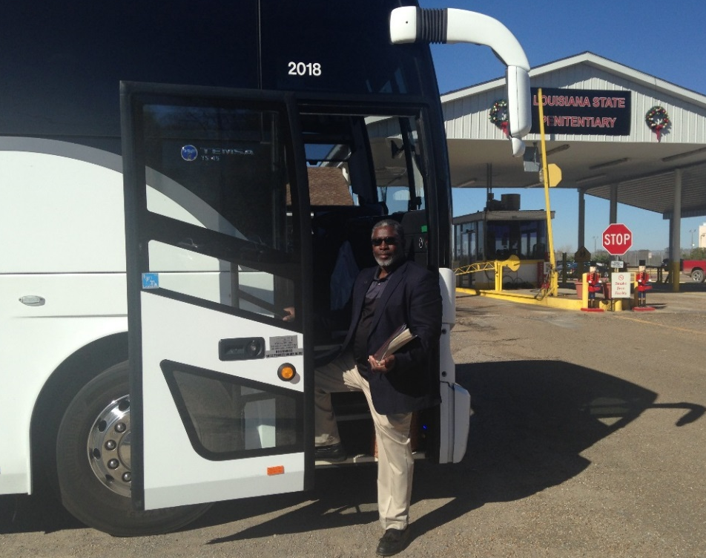
Trip Date
May 11, 2019
June 15, 2019
August 10, 2019
November 16, 2019
December 14, 2019

PLEASE RESERVE YOUR SEAT EARLY
ALL SEATS MUST BE RESERVED

To reserve a seat on the bus call 318-458-4229. Please leave your name and a phone number, we will return your call to reserve your seat on the bus.

Buses will leave from Fellowship of Christ Missionary Baptist Church, 375 W 75th Street, Shreveport (corner of Linwood Avenue and W 75th)

Passengers are asked to be at the Church at 3:30AM to board the bus at 3:45AM and be prepared to leave at 4.00AM. The bus will arrive back in Shreveport at approximately 7:30PM.

