**BUS TO ANGOLA PRISON!**

Do you have a loved one incarcerated at Louisiana State Penitentiary at Angola? Take advantage of this **FREE** transportation to help them stay connected!

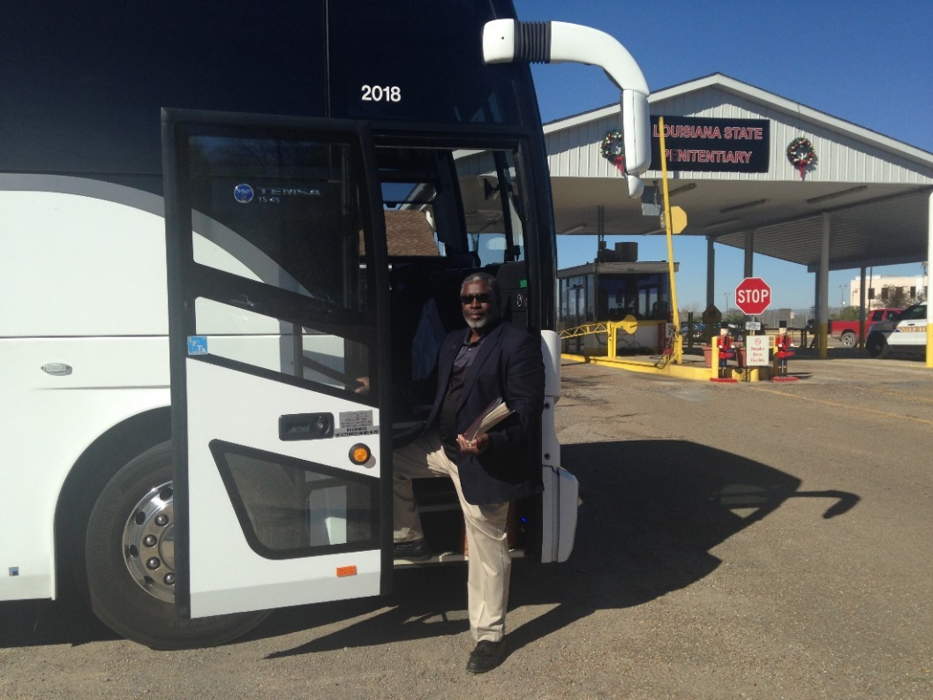

**Dates**

***February 8. 2020***

***May 9, 2020***

***June 13, 2020***

***August 15, 2020***

***November 14, 2020***

***December 12, 2020***

**ALL SEATS MUST BE RESERVED IN ADVANCE**

To reserve a seat on the bus call **318-458-4229**. Please speak clearly and leave your name and phone number, we will return your call to reserve your seat on the bus.

Buses will leave from **Fellowship of Christ Missionary Baptist Church, 375 W 75th Street, Shreveport (corner of Linwood Avenue and W 75th)**

Passengers are asked to be at the Church at **4:30AM to board the bus at 4:45AM and be prepared to leave at 5.00AM**. The bus will arrive back in Shreveport at approximately 8:30PM.